**Title:** CS1026 Lab 1 (AND Gate)

**Date:** 6/10/2016

**Aim:** To design, build and test a circuit to experimentally

determine the truth table of a 7400 2 Input NAND gate.

**Truth Table:**

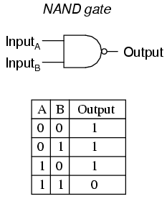[1]

**Analysis:**

* I began by examining the circuit diagram as shown below.
* I then proceeded to assemble my circuit to design logic that would enable me to create a truth table for a 7400 2 Input NAND Gate.
* I then turned the voltage to 5V and allowed current to flow through the circuit.
* I varied the switches positions (on/off) using the same voltage and current.
* I observed the resulting effect of changing each switches position on the LED light.

**Circuit Diagram:**

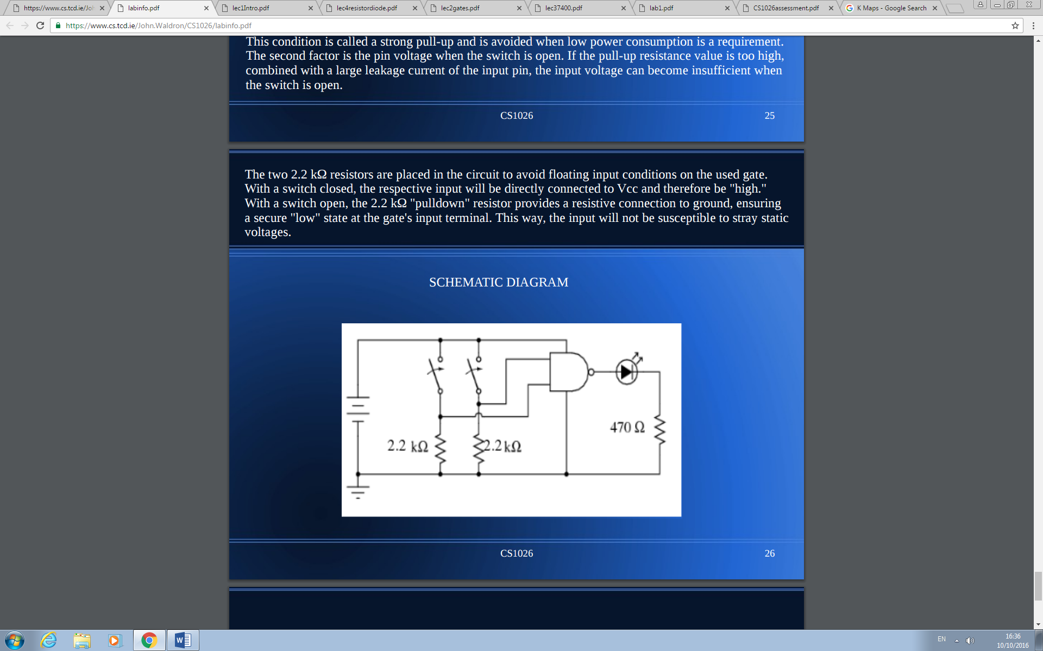

**Test Results:**

|  |  |  |
| --- | --- | --- |
| **Input 1** | **Input 2** | **LED** |
| 0 | 1 | 1 |
| 0 | 0 | 1 |
| 1 | 0 | 1 |
| 1 | 1 | 0 |

*0 = off*

*1 = on*

1. https://www.ibiblio.org/kuphaldt/electricCircuits/Digital/04124.png